Northamptonshire Family History Society (NFHS) Footprints. Vol 3 (1981/82)

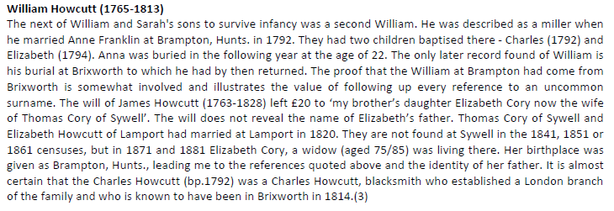
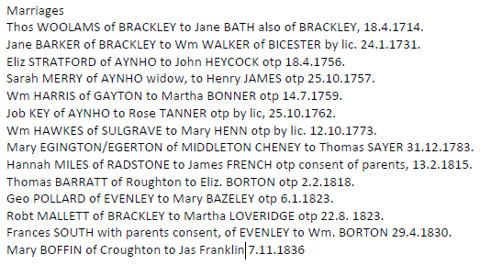

Northamptonshire Family History Society (NFHS) Footprints. Vol 8 (1986/87)
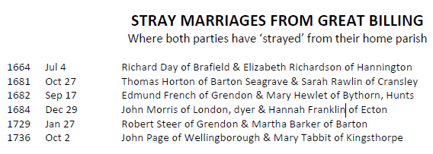
Northamptonshire Family History Society (NFHS) Footprints. Vol 9 (1987/88)
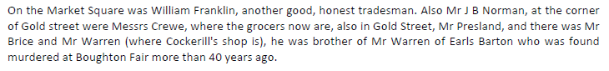

Northamptonshire Family History Society (NFHS) Footprints. Vol 10 (1988/89)
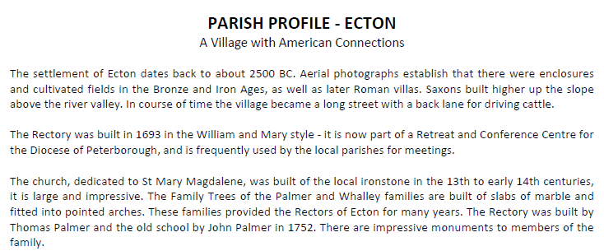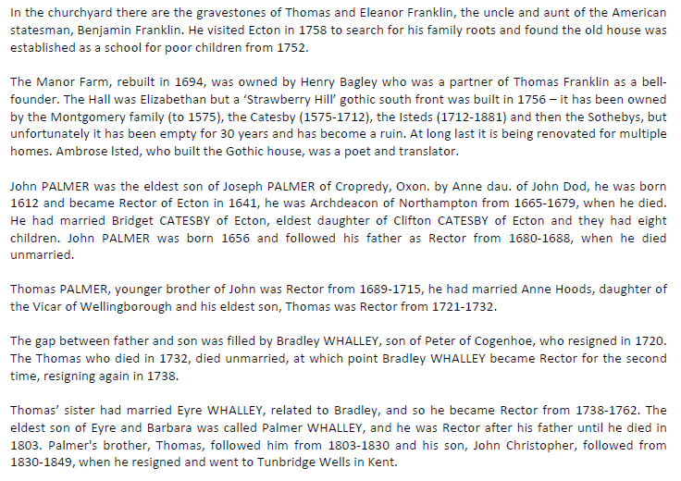

Northamptonshire Family History Society (NFHS) Footprints. Vol 13 (1991/92)
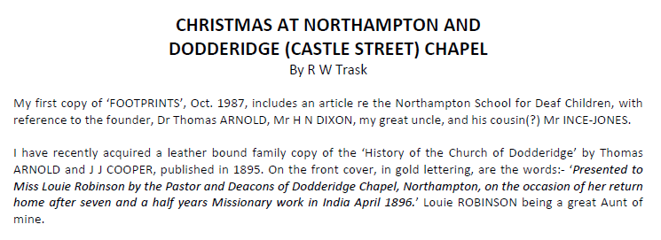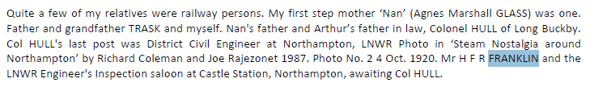

Northamptonshire Family History Society (NFHS) Footprints. Vol 14 (1992/93)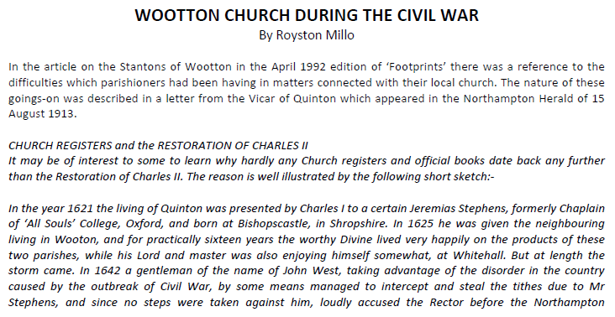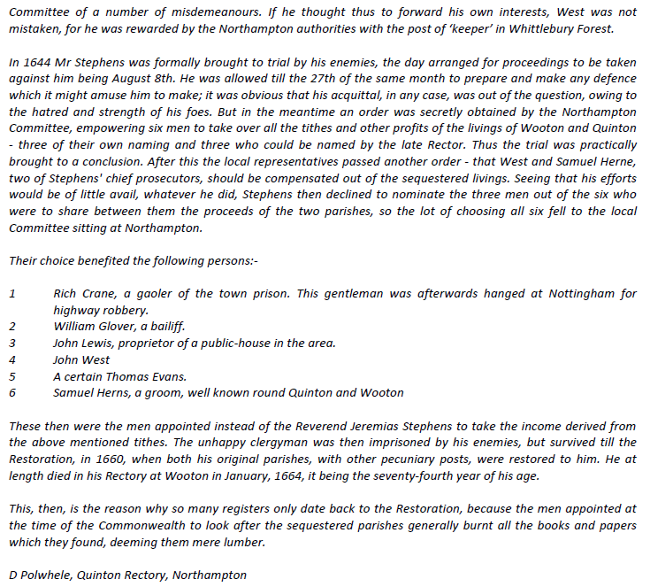 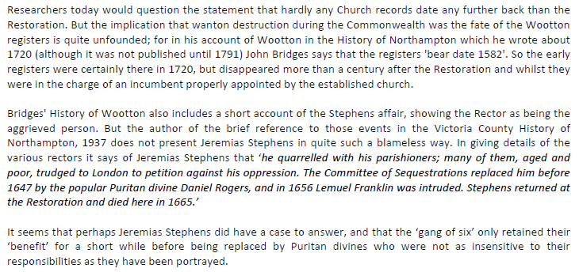
Northamptonshire Family History Society (NFHS) Footprints. Vol 19 (1997/98)
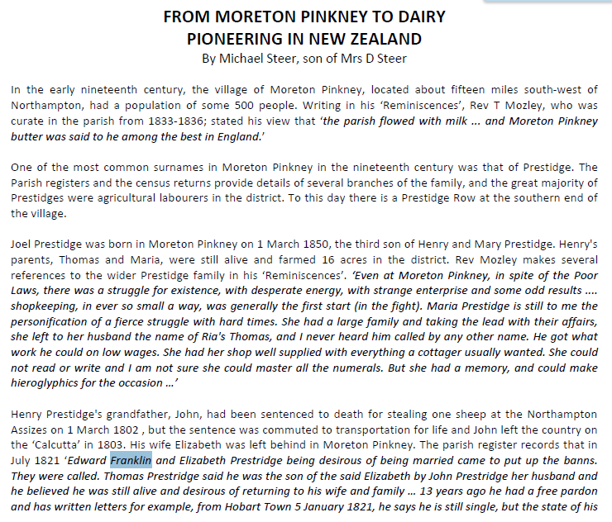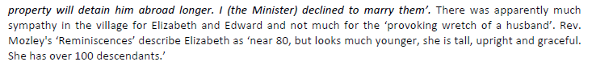

Northamptonshire Family History Society (NFHS) Footprints. Vol 26 (2004/05)
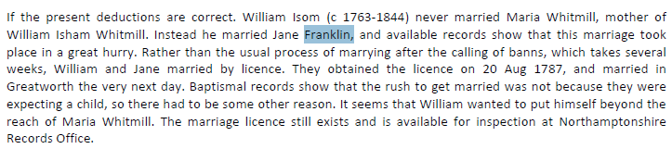
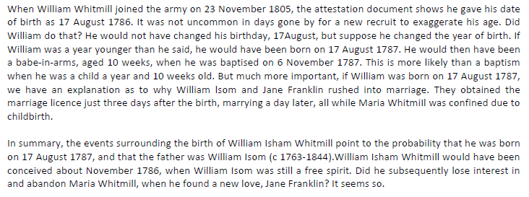
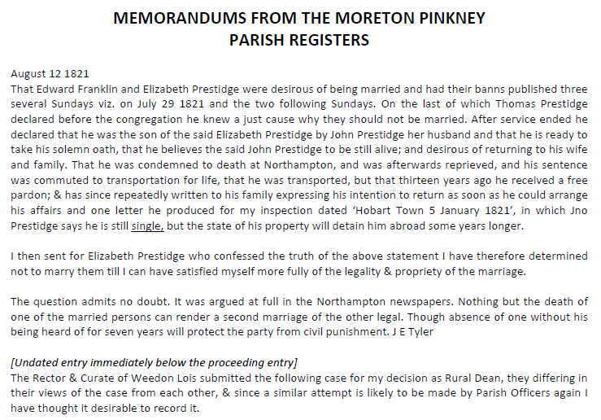

Northamptonshire Family History Society (NFHS) Footprints. Vol 27 (2005/06)
