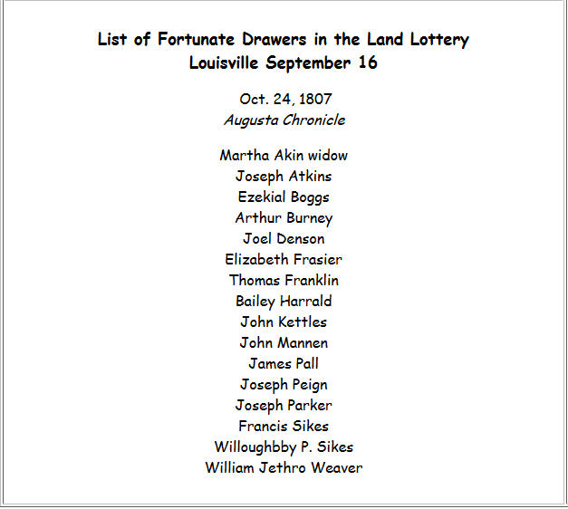
http://georgiagenealogy.org/wilkinson/1807.html
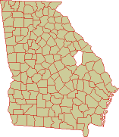
Louisville, Jefferson county, GA: Jefferson County was created from Burke and Warren counties on Feb. 20, 1796 by an act of the General Assembly (Ga. Laws 1796, p. 7). Georgia’s 23rd county was named for former U.S. secretary of state and author of the Declaration of Independence, Thomas Jefferson. Warren was created in 1793 from Wilkes.

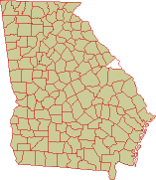
Augusta, Richmond county, GA: The land that would form Richmond County was ceded to the English by the Creeks in the Treaty of Savannah on May 21, 1733, confirmed and expanded by agreements of 1735 and 1736. By an act of March 15, 1758, the colonial legislature created seven parishes. The area of present-day Richmond County primarily fell within St. Paul Parish. With the outbreak of the American Revolution, Whig forces took control of government in Georgia. On Feb. 5, 1777, they adopted the state’s first constitution—the Constitution of 1777. Art. IV of that document transformed the existing colonial parishes into seven counties, with Indian ceded lands forming an eighth county. Richmond County, which was second on the list and thus is considered Georgia’s second county, consisted of all of St. Paul Parish. The county was named for the third Duke of Richmond, Charles Lenox (1735-1806), who was British secretary of state and sympathetic to the cause of the American colonies.

Wilkinson County
 |  |  | 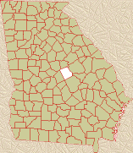  Click map for more  county information |  | On June 16, 1802, the Creek Indians and U.S. commissioners signed the Treaty of Fort Wilkinson, which ceded Creek lands in two different areas to Georgia. The northern cession involved land west of the Oconee River, which the legislature divided into two new counties -- Wilkinson and Baldwin -- on May 11, 1803 (Ga. Laws 1803 Extra. Ses., p. 3).  In 1805, the Creeks signed the Treaty of Washington, which extended Georgia westward to the Ocmulgee River. An act of June 26, 1806 added lands ceded by the Creeks to Baldwin and Wilkinson counties (Ga. Laws 1806 Extra. Ses., p. 3).  In an act of Dec. 10, 1807, Laurens and Telfair counties were created entirely from Wilkinson County (Ga. Laws 1807, p. 3). In an act of Dec. 14, 1809, Twiggs County was created entirely from Wilkinson County (Ga. Laws 1809, p. 75).
 |  | 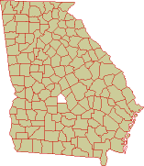
Pulaski County was created from Laurens County on Dec. 13, 1808 by an act of the General Assembly (Ga. Laws 1808, p. 52). In 1870, the legislature used a portion of Pulaski County to help create Dodge County. In 1912, Georgia voters approved a constitutional amendment creating Bleckley County from the northwestern half of Pulaski County.
Georgia’s 36th county was named for Count Casimir Pulaski of Poland. Pulaski, who fought on behalf of the American cause in the Revolutionary War, was mortally wounded in 1779 during an attack on British forces that had seized Savannah.
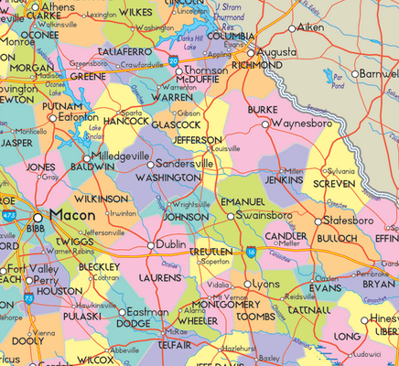http://www.ezilon.com/maps/images/usa/georgia-county-map.gif
See also: http://www.mapofus.org/georgia/

