Washington county, GA LDS films-
(check by number to see if any are at Clayton already by chance-online AND in drawer at Clayton)

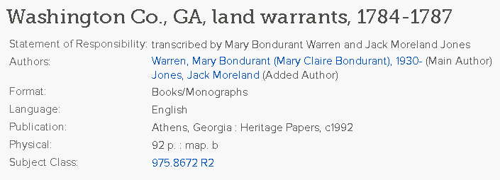975.8 W291 GA
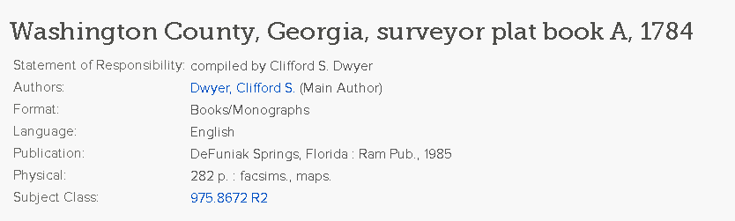975.8 D993 GA 1784

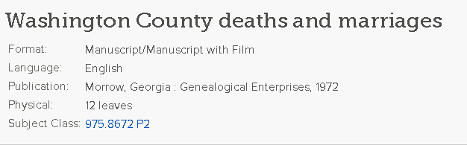
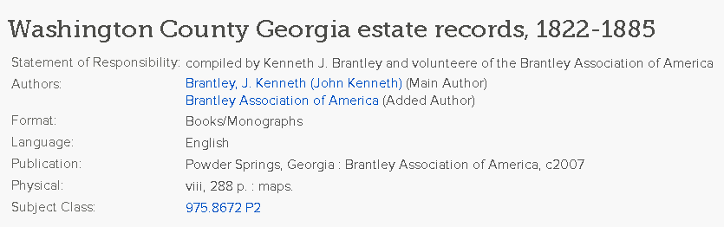B821 WASHI GA
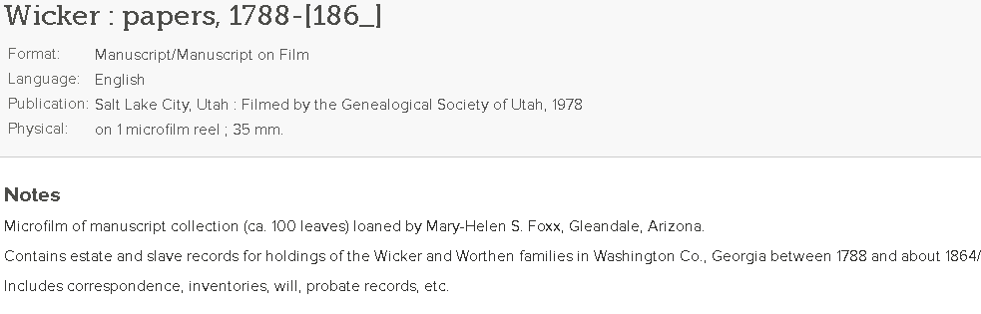

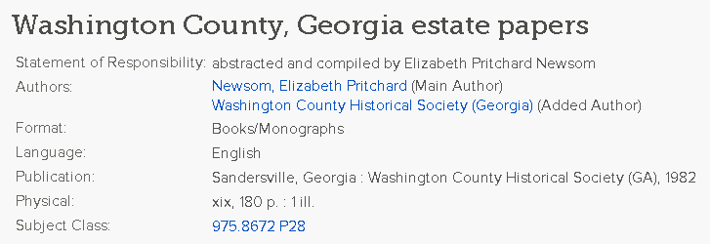
1701 9th Avenue North
Texas City, TX 77590
Phone: (409) 643-5979
Fax : (409) 948-1106
Monday, Tuesday, Wednesday: 9 a.m. to 9 p.m.
Thursday, Friday: 9 a.m. to 6 p.m.
Saturday: 10 a.m. to 4 p.m.

