https://search.ancestry.com/cgi-bin/sse.dll?db=AlabamaOfficersReg&gss=sfs28_ms_db&new=1&rank=1&msT=1&gsln=Franklin&gsln_x=1&MSAV=1&uidh=86u
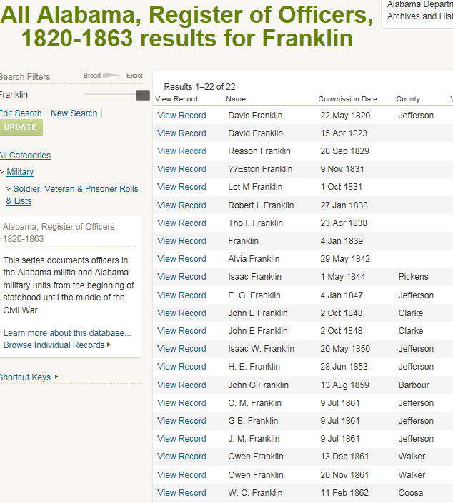

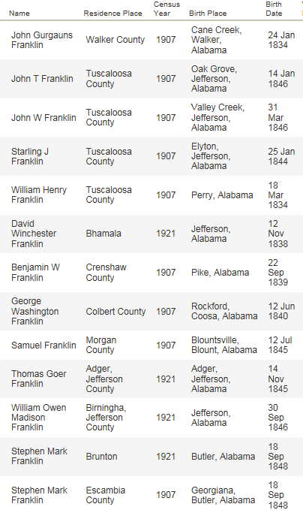
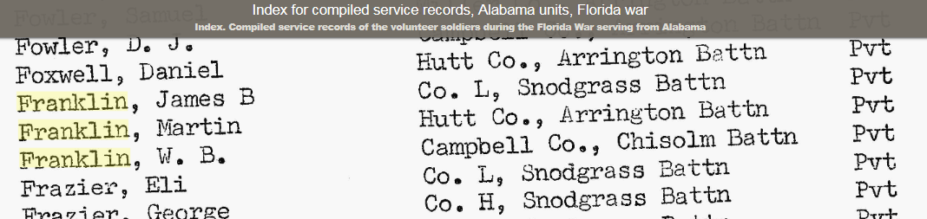

Index to Florida militia muster rolls, Seminole Indian wars
Key-The ten volume set of books that this indexes is called "Florida militia
muster rolls, Seminole Indian wars," published in St. Augustine, Florida
by the Florida Department of Military Affairs. THE NUMBERS AFTER EACH NAME INDICATE THE VOLUME AND PAGE NUMBERS.
Franklin, George, 09:102-103
Pvt, 04:095, 09:104-105, 09:106-107, 09:108-109, 09:114-115, 09:118-119,
09:120-121, 09:124-125, 09:126-127, 09:128-129, 09:130-131, 09:1164-1175
Franklin, Selby
Pvt, 09:106-107, 09:108-109, 09:114-115, 09:118-119, 09:120-121, 09:124-125,
09:130-131, 09:1164-1175
Franklin, Wyatt
Sgt, 05:103-104

